1. SQL Exercise - Advanced concepts
Advanced SQL Exercise for Online Retail Store
Exercise 1:
Ranking and Window Functions Goal: Use ROW_NUMBER(), RANK(), DENSE_RANK(), OVER(), and PARTITION BY. Scenario: Find the top 3 most expensive products in each category using different ranking functions. Steps: 1. Use ROW_NUMBER() to assign a unique rank within each category. 2. Use RANK() and DENSE_RANK() to compare how ties are handled. 3. Use PARTITION BY Category and ORDER BY Price DESC.
Solutions:-
ROW_NUMBER()
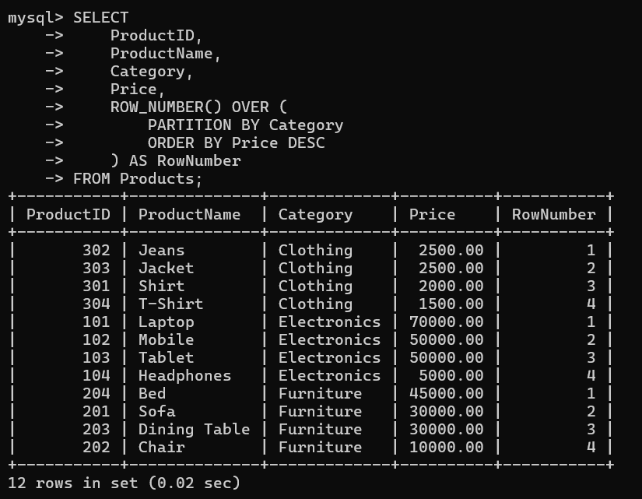
RANK()
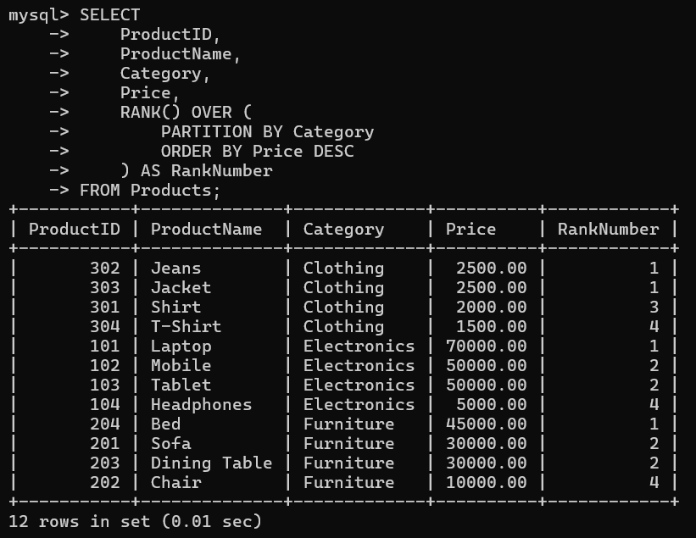
DENSE_RANK()
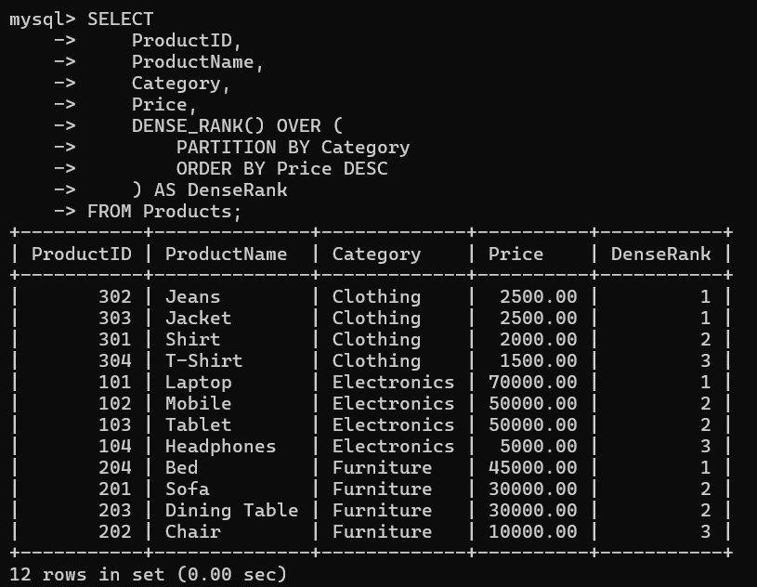

Top 3 Most Expensive Products in Each Category
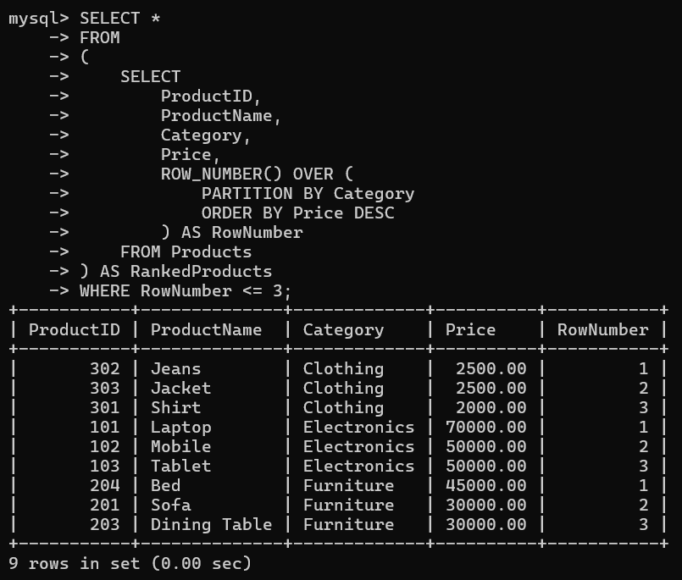

4. SQL Exercise - Stored procedure

Exercise 1:
Create a Stored Procedure Goal: Create a stored procedure to retrieve employee details by department. Steps:
1. Define the stored procedure with a parameter for DepartmentID.
2. Write the SQL query to select employee details based on the DepartmentID.
3. Create a stored procedure named `sp_InsertEmployee` with the following code: CREATE PROCEDURE sp_InsertEmployee @FirstName VARCHAR(50), @LastName VARCHAR(50), @DepartmentID INT, @Salary DECIMAL(10,2), @JoinDate DATE AS BEGIN INSERT INTO Employees (FirstName, LastName, DepartmentID, Salary, JoinDate) VALUES (@FirstName, @LastName, @DepartmentID, @Salary, @JoinDate); END;

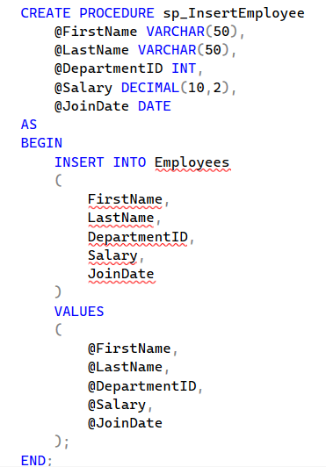

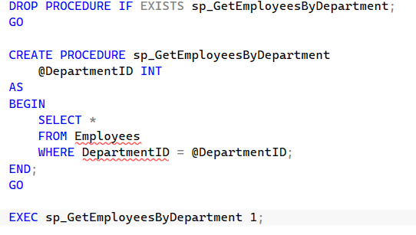
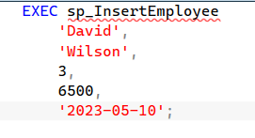
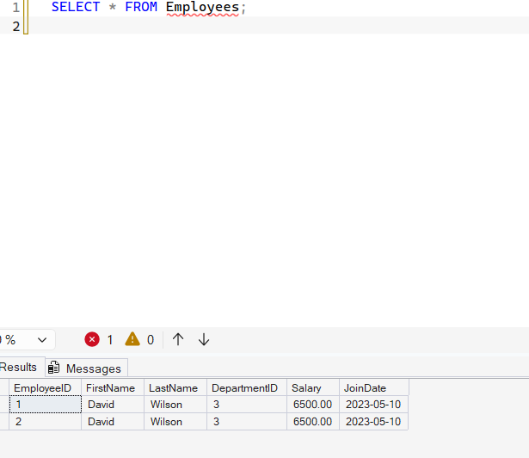

Exercise 5:
Return Data from a Stored Procedure Goal: Create a stored procedure that returns the total number of employees in a department. Steps:
1. Define the stored procedure with a parameter for DepartmentID.
2. Write the SQL query to count the number of employees in the specified department.
3. Save the stored procedure by executing the Stored procedure content.

